Import Content into Course
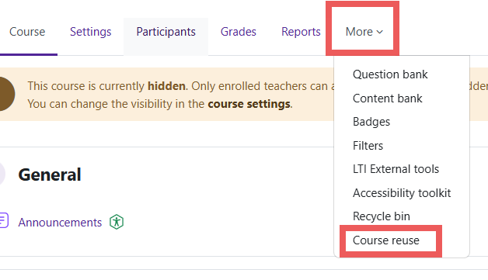
Log in to Moodle and go to the course you want to import content into. At the top of the screen, click on More and then choose Course Reuse.

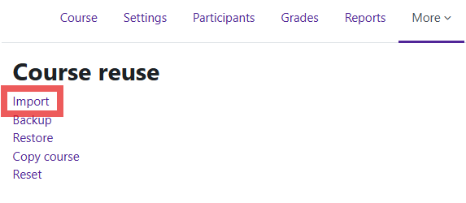
In the Course Reuse menu, you will click on the first option, Import.

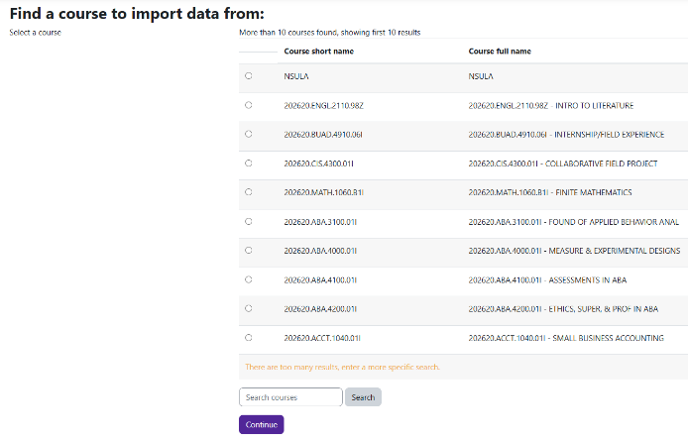
Next, select the course you would like to copy content from. If the course is not provided in the list shown, use the search box, and type the complete course name of the course you want to copy content from. Example, 202620.FA.1040.02I and then click Search.

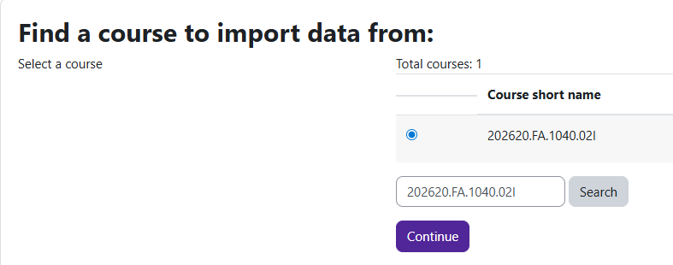

Once found, click on the circle beside the course name and press Continue located at the bottom.

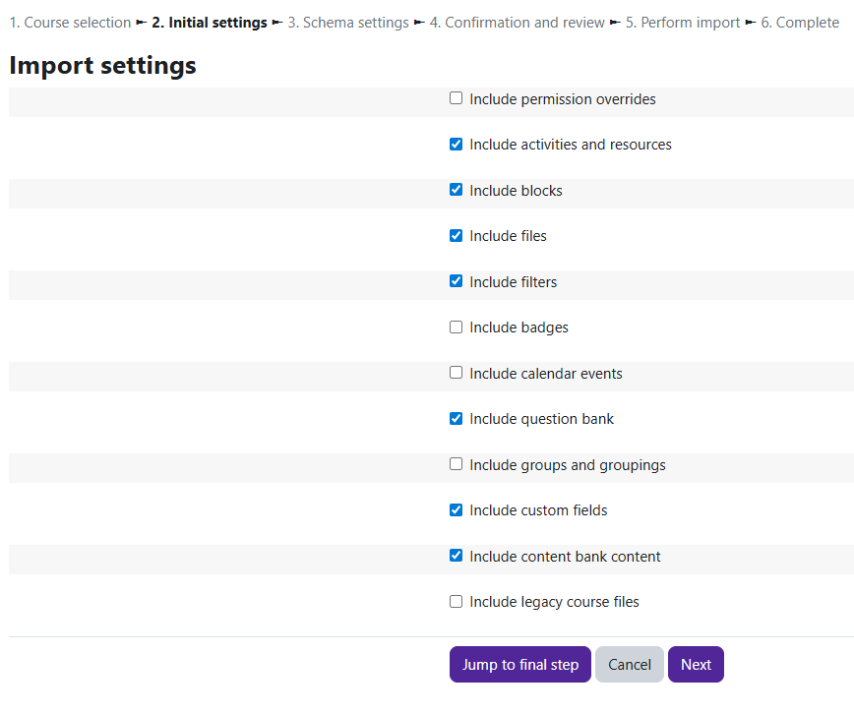
The import settings screen will show everything that will be copied over. Only modify the checked/unchecked when you need to copy specific pieces of the course.

Click on the Next button to proceed.

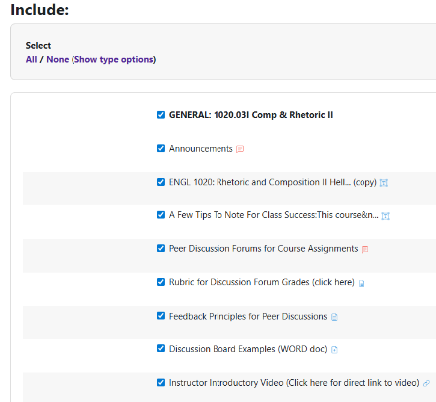
The Include screen will show everything that will be copied over. Please review this page to make sure no Turnitin assignments are checked.

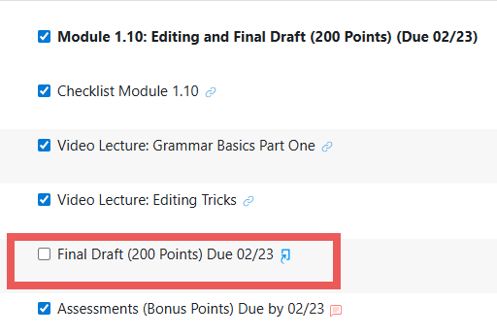
If you have Turnitin assignments in your class, uncheck them because they will not copy over correctly.


Once you have verified that you don’t have any Turnitin assignments checked, you will click the Next button located at the bottom of the screen.

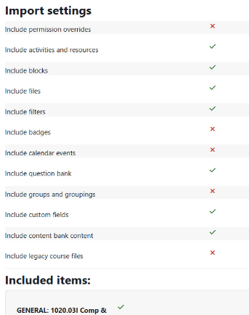
The Import Settings screen recaps the changes you made on the previos screen. If changes are incorrect, scroll to the bottom and click the Previous button to redo the changes. If the changes are correct, click Perform Import.

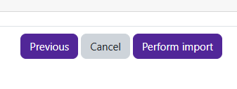

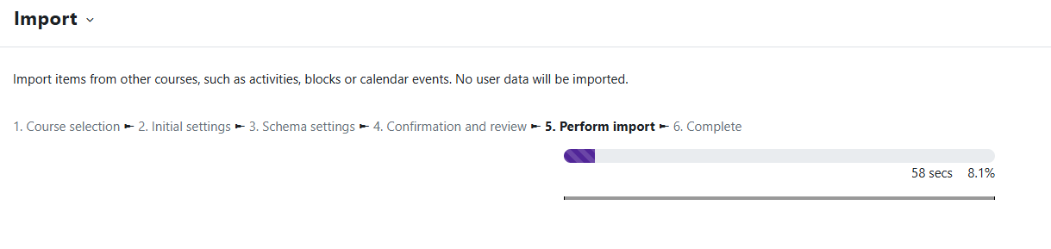
You will then see a screen showing the percentage complete of your import with an estimated time of completion.

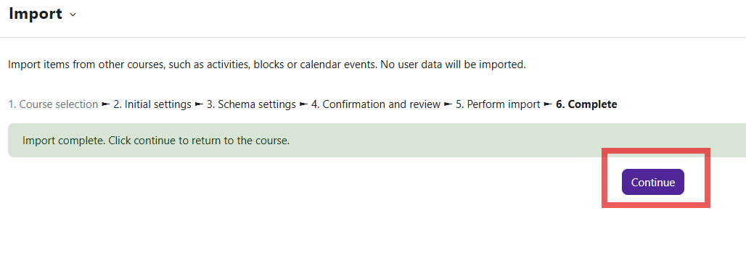
Once you reach 100%, the screen will state the import is complete. At the bottom of the screen, click Continue to view the course content.

